

ALIA

AYOUB

DIANA

HAIROULLA

HALIL-NESRI

MIA

SHEMS

SOFIANE

ALIA
AYOUB
DIANA
HAIROULLA
HALIL-NESRI
MIA
SHEMS
SOFIANE



HANNAH
HIDAYA
JAD
KILUANJI
LAGERTHA
LILLÉ
MAXIME
WASSIM

HANNAH
HIDAYA
JAD
KILUANJI
LAGERTHA
LILLÉ
MAXIME
WASSIM

Hannah
Hidaya
Jad
Kiluanji
Lagertha
Lillé
Maxime
Wassim

Anouck
Aya
Ivy
Julian
Mali
Milla
Noé
Sybille
Yassine
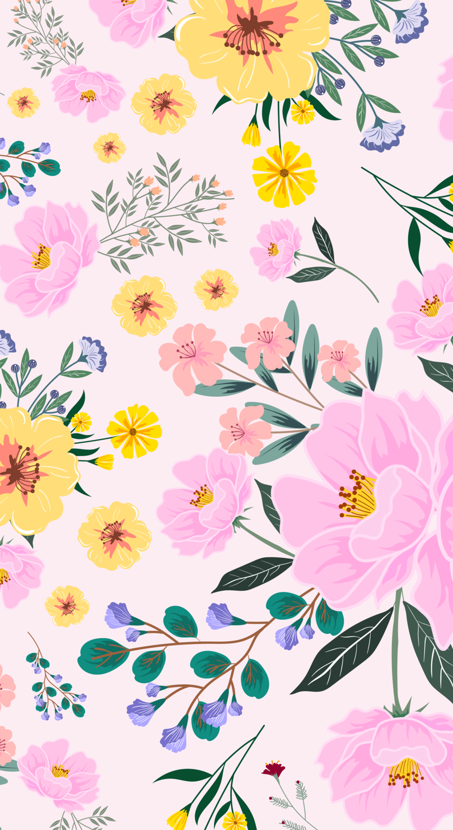
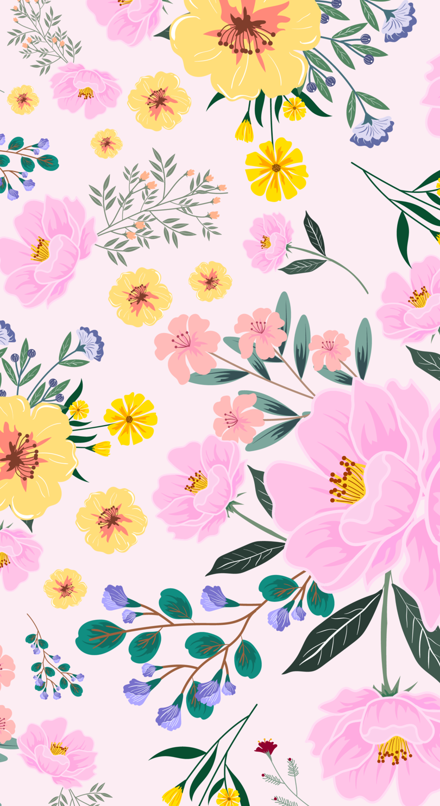

Anouck
Aya
Ivy
Julian
Mali
Milla
Noé
Sybille
Yassine

